**4.1 – Quadratic Functions and Transformations**

**Quadratic Function:** a function of the form

$f\left(x\right)=ax^{2}+bx+c$ where $a≠0$

**Parabola:** the “U shaped” graph that is formed by a quadratic function

**Vertex Form:** another way of writing a quadratic equation,

$f\left(x\right)=a{(x-h)}^{2}+k$ where $a≠0$

Note: it is called vertex form because are able to easily identify the vertex

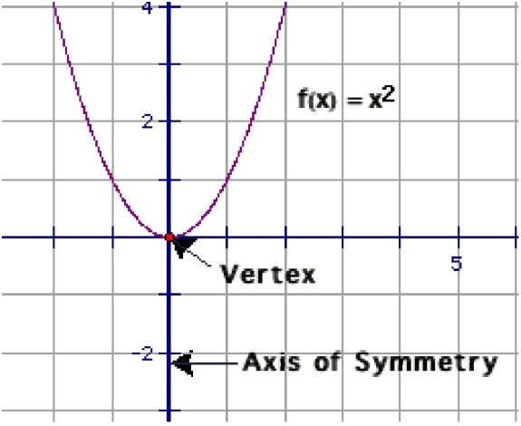**Vertex:** the highest (maximum) or lowest (minimum) point of a parabola where the axis of symmetry intersects our parabola (h, k)

**Axis of Symmetry:** The vertical line that divides are parabola into two mirror images of each other by passing through the vertex.  **Parent Graph $f\left(x\right)=x^{2}$**

**\*\*Remember the impact of a, h, and k.\*\***

-If a is positive our “U” opens up

-If a is negative our “U” opens down

-If a > 0 there is a stretch (narrow)

-If 0 < a < 1 there is a compression (wide)

-h moves the graph left and right (the x-value of the vertex)

-k moves the graph up and down (the y-value of the vertex)

**Example: Graph $f\left(x\right)=\frac{1}{4}x^{2}$**

Step 1: Plot the vertex (0,0). Draw the axis of symmetry, x=0.

Step 2: Find and plot two points on one side of axis of symmetry.

Step 3: Plot the corresponding points on the other side of the axis   
 of symmetry.

Step 4: Sketch the curve.

X Y

**1 1/4**

**2 1**

**Example: $g\left(x\right)=x^{2}+2$**

Step 1: Plot the vertex (0,2). Draw the axis of symmetry, x=0.

Step 2: Find and plot two points on one side of axis of symmetry.

Step 3: Plot the corresponding points on the other side of the axis   
 of symmetry.

Step 4: Sketch the curve.

X Y

**1 3**

**2 6**

**Example: $h\left(x\right)={(x-3)}^{2}$**

Step 1: Plot the vertex (3,0). Draw the axis of symmetry, x=3.

Step 2: Find and plot two points on one side of axis of symmetry.

Step 3: Plot the corresponding points on the other side of the axis   
 of symmetry.

Step 4: Sketch the curve.

X Y

**4 1**

**5 4**

**Example: $f\left(x\right)={2\left(x+1\right)}^{2}-5$**

**What are the vertex, the axis of symmetry, the maximum or minimum, the domain and range.**

Step 1: Plot the *vertex (-1,-5)*. Draw the *axis of symmetry, x=-1*.

Step 2: Find and plot two points on one side of axis of symmetry.

Step 3: Plot the corresponding points on the other side of the axis   
 of symmetry.

Step 4: Sketch the curve.

X Y

**0 -3**

**1 3**

Since a=2 I know that the graph opens up so I have a minimum. The k=-5 so *my minimum is at -5*.

*Domain* (the x-values) has no restrictions so it is *All Real Numbers*

*Range* (the y-values) since our graph goes down to -5, there is a restriction. Therefore our range is *All Real Numbers $≥-5$* .

**HMWK: pg 198 #4-6, 13-37 (odd),**